Project: Woodson Park Academy & YMCA-ELC
Week Ending: November 8th, 2019

THIS WEEK:
- Pour kitchen area slab
- Start Masonry
- Retaining wall backfill
- Cut Parking lot grades

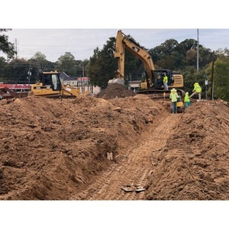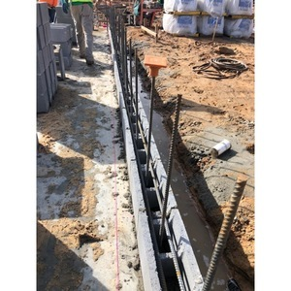

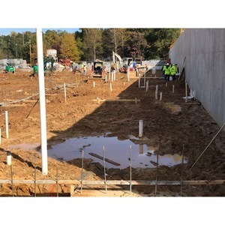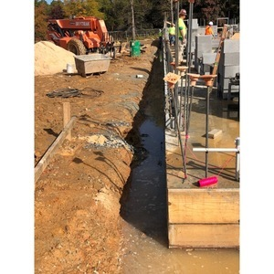

NEXT WEEK – November 11th thru November 15th:
- Continue underslab MEP
- Start slab prep at Gym area
- Pour Gym area slab
- Start upper level Aggregate Piers

PAYMENT STATUS:
- Gmp#1 $3,703,488.00
  - Paid to date amount $1,469,778.75
- GMP#2 $28,686,295.00
  - Paid to date amount $1,124,342.82

SCHEDULED DATE OF SUBSTANTIAL COMPLETION
- WPA – September 28, 2020
- YMCA-ELC - September 14, 2020

PREPARED BY:
- Matt Dauber, Carroll Daniel Construction Co.

